MAJOR ASSIGNMENT REPORT ON
Agricultural Commodity Price Prediction
Using Machine Learning And Deep Learning Techniques

B.Tech. Computer Science and Engineering(AIML)
Semester: 5th
Section: 23412C3
Course Title & Code: DEEP LEARNING WITH TENSORFLOW 1 (CSE3793)

Submitted By:
Student Name: Tribhuwan Singh Registration No: 2341019538
Student Name: Surajit Sahoo Registration No: 2341019165
Student Name: Badri Narayan Patra Registration No: 2341016251


CENTER FOR ARTIFICIAL INTELLIGENCE & MACHINE LEARNING
DEPARTMENT OF COMPUTER SCIENCE AND ENGINEERING
FACULTY OF ENGINEERING AND TECHNOLOGY (ITER)
SIKSHA ‘O’ ANUSANDHAN
(Deemed to be University)
BHUBANESWAR, ODISHA

ABSTRACT
Agricultural commodity prices are highly volatile in nature and are influenced by a wide range of interdependent factors such as seasonal supply variations, market demand, weather conditions, transportation and logistics constraints, and government policies. These frequent price fluctuations directly affect farmers’ income stability, supply chain planning, consumer affordability, and overall food security. Accurate price forecasting therefore plays a crucial role in supporting informed decision-making for various stakeholders in the agricultural sector.
This project focuses on the analysis and prediction of agricultural commodity prices using historical market data and deep learning–based time series techniques. The study utilizes an Indian agricultural commodity price dataset containing information such as state, district, market, commodity type, arrival date, and minimum, maximum, and modal prices. An extensive exploratory data analysis (EDA) is performed to understand price trends, seasonality, volatility, and data distribution patterns. Based on the insights obtained from EDA, relevant features such as lag-based variables, rolling statistical measures, and calendar-based features are engineered to capture temporal dependencies in price movements.
To evaluate the suitability of deep learning models for this task, Long Short-Term Memory (LSTM), Gated Recurrent Unit (GRU), and Transformer-based architectures are considered for price prediction. The models are assessed using standard evaluation metrics including Root Mean Square Error (RMSE), Mean Absolute Error (MAE), and R² score, along with graphical comparison of actual and predicted prices. The results indicate that while deep learning models have the potential to learn temporal patterns, their performance is significantly constrained by limited and irregular time-series data available for individual commodities.
Overall, the study highlights the importance of data quality and sufficient historical depth for reliable deep learning–based price forecasting. The findings emphasize that strong exploratory analysis and feature engineering are essential prerequisites for effective model performance and provide valuable insights for future research involving extended datasets and additional external influencing factors.

TABLE OF CONTENTS
Contents Page No.
1. Introduction 5
1.1 Background of the Problem 5
1.2 Importance of the Problem 5
1.3 Role of Deep Learning in Time Series Prediction 6
1.4 Motivation 6
1.5 Problem Statement 6
1.6 Objectives 6
1.7 Scope 7
2. Literature Review 8
2.1 Time Series Forecasting Using Statistical Models 8
2.2 Machine Learning Approaches for Price Prediction 8
2.3 Recurrent Neural Networks for Time Series Prediction 8
2.4 Gated Recurrent Unit (GRU) Models 8
2.5 Attention Mechanisms and Advanced Deep Learning Models 9
2.6 Deep Learning Models in Agricultural Price Forecasting 9
2.7 Research Gap 9
3. System Requirements 10
3.1 Hardware Requirements 10
3.2 Software Requirements 10
4. Dataset Description 11
4.1 Source and Purpose 11
4.2 Dataset Structure and Fields 11
4.3 Dataset Size and Splits 12
4.4 Characteristics of Agricultural Price Data 13
4.5 Data Preprocessing and Feature Preparation 13
4.6 Relevance to Price Prediction Tasks 13
5. Proposed Methodology 14
5.1 Data Pre-processing 14
5.2 Feature Selection and Engineering 14
5.3 Workflow Diagram 15
5.4 Model Architecture 15
5.4.1 Random Forest Regression Model 15
5.4.2 Recurrent Neural Network Models (LSTM and GRU) 16
5.4.3 Transformer-Based Models 16
5.5 Hyperparameter Details 16
5.6 Loss Functions and Evaluation Criteria 16
6. Result and Evaluation 17
6.1 Model Architecture Analysis 17
6.2 Epoch-wise Error Trend Visualisation 17
6.3 Training and Testing Performance Analysis 17
6.4 Quantitative Evaluation and Visualisation 18
6.5 Model Complexity and Parameter Analysis 19
7. Benefits of the Proposed System 20
8. Limitations and Challenges 21
9. Conclusion 22
10. Future Scope 23
References 24

1. Introduction
Agriculture is one of the most important sectors of the Indian economy, playing a crucial role in ensuring food security and rural livelihoods. Agricultural commodities such as cereals, vegetables, fruits, and pulses are traded daily in markets across the country. However, the prices of these commodities do not remain constant and are highly sensitive to a wide range of factors. Farmers, traders, consumers, and policymakers are often affected by sudden price fluctuations, which create uncertainty and economic instability.
With the increasing availability of digital market records and historical price data, it has become possible to analyse agricultural price behaviour more systematically. Traditional approaches to price prediction are often unable to capture complex temporal patterns and non-linear relationships present in real-world agricultural data. As a result, there is a growing interest in applying data-driven and intelligent techniques to understand price trends and forecast future movements more accurately.
This project focuses on the analysis and prediction of agricultural commodity prices using historical market data and deep learning–based time series approaches. By leveraging modern machine learning techniques, the study aims to explore whether deep learning models can effectively capture temporal dependencies and provide reliable short-term and mid-term price predictions.

1.1 Background of the Problem
Agricultural commodity prices are influenced by multiple interdependent factors such as seasonal supply variations, weather conditions, market demand, transportation and storage constraints, government policies, and global economic trends. These factors interact dynamically, making price movements highly irregular and difficult to predict. In many cases, farmers are forced to sell their produce at unfavourable prices due to a lack of timely price information and forecasting support.
The rapid digitisation of agricultural markets has resulted in the availability of large volumes of historical price data across different regions and commodities. While this data provides an opportunity for deeper analysis, extracting meaningful insights from such time-series data remains a challenge. Variations in data frequency, missing records, and irregular time intervals further complicate the prediction process. Therefore, an intelligent and robust forecasting system is required to analyse historical trends and assist stakeholders in making informed decisions.

1.2 Importance of the Problem
Accurate prediction of agricultural commodity prices is of significant importance for multiple stakeholders. For farmers, reliable price forecasts can support better crop planning, harvesting decisions, and market selection, ultimately improving income stability. For traders and supply chain stakeholders, price predictions help optimise procurement, storage, and distribution strategies.
From a consumer and policy perspective, agricultural price forecasting contributes to better market regulation, inflation control, and food security planning. Sudden price spikes or crashes can have serious economic and social consequences. Therefore, developing intelligent systems that can analyse historical data and provide early insights into price trends is essential for creating a more stable and transparent agricultural market ecosystem.

1.3 Role of Deep Learning in Time Series Prediction
Time series prediction involves analysing sequential data points collected over time to identify patterns, trends, and dependencies. Traditional statistical models often rely on linear assumptions and fixed patterns, which limit their ability to handle complex and non-linear agricultural data. Deep learning models, on the other hand, are designed to automatically learn temporal relationships from data without requiring explicit rule-based assumptions.
Models such as Long Short-Term Memory (LSTM), Gated Recurrent Unit (GRU), and Transformer-based architectures are particularly effective in handling time-dependent data. These models are capable of learning long-term dependencies, capturing seasonal variations, and modelling non-linear price behaviour. As a result, deep learning has emerged as a promising approach for agricultural commodity price forecasting, especially when sufficient historical data is available.

1.4 Motivation
The motivation behind this project is to explore the practical applicability of deep learning models for agricultural price prediction using real-world market data. While many studies apply advanced models without evaluating data suitability, this work emphasises understanding the dataset characteristics before concluding. The project aims to analyse whether deep learning techniques can genuinely provide meaningful insights or whether data limitations significantly affect model reliability.
Another key motivation is to develop a methodologically sound forecasting framework that prioritises exploratory data analysis, feature engineering, and careful model evaluation. By identifying both strengths and limitations, the study seeks to present a realistic assessment of deep learning approaches in the agricultural domain.

1.5 Problem Statement
The primary challenge addressed in this project is the design and evaluation of an intelligent system capable of predicting agricultural commodity prices using historical market data. The task involves analysing complex time-series data influenced by multiple external factors and learning meaningful temporal patterns that can support short-term and mid-term price forecasting.
The problem is not limited to implementing deep learning models but also includes assessing data quality, handling irregular and sparse observations, and ensuring that the generated predictions are reliable and interpretable. Achieving accurate forecasting under such constraints remains a significant challenge in agricultural price prediction.

1.6 Objectives
The objectives of this project are as follows:
• To analyse historical agricultural commodity price data and understand price behaviour over time
• To perform exploratory data analysis (EDA) to identify trends, seasonality, and volatility
• To select and engineer relevant features such as lag variables, rolling statistics, and calendar-based features
• To apply deep learning models such as LSTM, GRU, and Transformer for price prediction
• To evaluate model performance using metrics such as RMSE, MAE, and R² score
• To analyse the advantages and limitations of different deep learning models based on experimental outcomes

1.7 Scope
The scope of this project is limited to the analysis and prediction of agricultural commodity prices using historical market data from Indian agricultural markets. The study primarily focuses on short-term and mid-term price forecasting using deep learning–based time series models.
Future extensions of this work may include the use of longer and more continuous historical datasets, integration of external factors such as weather data, inflation indices, and fuel prices. Additionally, the proposed system can be extended for real-time forecasting and decision support applications for farmers and policymakers.

2. Literature Review
The field of agricultural price forecasting has gained significant attention over the years due to the growing availability of historical market data and the increasing need for accurate decision-making tools in the agricultural sector. Early approaches to price prediction primarily relied on traditional statistical methods such as moving averages, autoregressive models, and regression-based techniques. While these methods were effective for capturing simple trends and seasonality, they often failed to model complex non-linear relationships and long-term dependencies present in real-world agricultural price data. With the advancement of machine learning and deep learning techniques, researchers have increasingly shifted towards data-driven models capable of learning temporal patterns directly from historical observations.

2.1 Time Series Forecasting Using Statistical Models
Initial research in agricultural commodity price prediction focused on classical time-series models such as ARIMA and seasonal ARIMA (SARIMA). These models assume linear relationships and require the data to be stationary, which limits their applicability in highly volatile agricultural markets. Although such models provide interpretable results, their performance deteriorates when prices are influenced by irregular fluctuations, external shocks, and non-linear interactions. As agricultural prices are often affected by multiple dynamic factors, traditional statistical methods alone are insufficient for reliable forecasting in complex scenarios.

2.2 Machine Learning Approaches for Price Prediction
To overcome the limitations of statistical models, machine learning techniques such as linear regression, decision trees, random forests, and support vector machines have been applied to agricultural price forecasting. These models improved prediction accuracy by capturing non-linear relationships between features and prices. However, most machine learning models treat data as independent observations and do not explicitly model temporal dependencies. As a result, their ability to learn long-term trends and sequential patterns remains limited, especially in time-series-driven domains such as commodity price prediction.

2.3 Recurrent Neural Networks for Time Series Prediction
Recurrent Neural Networks (RNNs) introduced a major advancement in time-series forecasting by enabling models to retain information from previous time steps. Long Short-Term Memory (LSTM) networks were specifically designed to address the vanishing gradient problem in traditional RNNs and have been widely used for financial and agricultural forecasting tasks. LSTM models are capable of learning long-term dependencies and capturing seasonal patterns in price data. Several studies have demonstrated improved forecasting accuracy using LSTM models compared to traditional machine learning approaches. However, LSTM performance is highly dependent on the availability of long and continuous time-series data.

2.4 Gated Recurrent Unit (GRU) Models
Gated Recurrent Units (GRUs) were introduced as a simplified alternative to LSTM networks, offering comparable performance with fewer parameters. GRU models reduce computational complexity while maintaining the ability to capture temporal dependencies. In agricultural price forecasting, GRUs have been shown to perform well when dataset size is limited, as they require less training time and are less prone to overfitting. Despite these advantages, GRU models may still struggle with highly irregular and sparse datasets, which are common in real-world agricultural markets.

2.5 Attention Mechanisms and Advanced Deep Learning Models
Recent studies have explored the use of attention mechanisms to enhance time-series forecasting performance. Attention allows models to focus on relevant time steps rather than treating all past observations equally. This approach improves interpretability and helps capture significant temporal patterns. Transformer-based models, which rely entirely on self-attention mechanisms, have further advanced time-series prediction by efficiently modeling long-range dependencies. Although transformers demonstrate strong performance in complex forecasting tasks, they typically require large datasets and substantial computational resources, which may limit their applicability in agricultural domains with sparse historical data.

2.6 Deep Learning Models in Agricultural Price Forecasting
Several researchers have applied deep learning models to agricultural commodity price prediction, reporting improved accuracy compared to traditional methods. These studies highlight the importance of feature engineering, including lag variables, rolling statistics, and calendar-based features, to enhance model learning. However, they also emphasize challenges such as data sparsity, missing values, and irregular time intervals. These limitations often restrict the generalization capability of deep learning models, especially when applied to individual commodities with limited historical records.

2.7 Research Gap
Despite the growing use of deep learning techniques in agricultural price forecasting, a clear research gap remains in evaluating the feasibility of advanced models under real-world data constraints. Many existing studies apply complex architectures without thoroughly assessing data quality, continuity, and suitability. Additionally, there is limited comparative analysis between LSTM, GRU, and Transformer-based models using consistent evaluation metrics such as RMSE, MAE, and R² score. This project addresses these gaps by systematically analysing dataset characteristics, applying multiple deep learning models, and critically evaluating their performance and limitations. The study aims to provide a balanced understanding of the trade-offs between model complexity, data availability, and prediction reliability in agricultural commodity price forecasting.

3. System Requirements
The development and evaluation of the proposed agricultural commodity price prediction system require adequate computational resources and software tools to ensure efficient data processing, model implementation, and performance evaluation. Since the project involves exploratory data analysis, feature engineering, and experimentation with deep learning models, both hardware and software requirements play an important role in achieving reliable results.

3.1 Hardware Requirements
The following hardware configuration is sufficient for implementing and evaluating the proposed system:
• A standard personal computer or laptop
• Processor: Intel Core i5 or equivalent (or higher)
• Minimum 8 GB RAM (16 GB recommended for deep learning experiments)
• GPU support (NVIDIA GPU recommended for faster model training, if available)
• Sufficient storage space for datasets and model outputs
Although deep learning models benefit from GPU acceleration, the experiments in this project can also be performed on CPU-based systems due to the limited size of the dataset.

3.2 Software Requirements
The following software tools and libraries are used for system development and experimentation:
• Operating System: Windows / Linux
• Programming Language: Python (version 3.8 or above)
• Development Environment: Jupyter Notebook / Google Colab
• Deep Learning Framework: TensorFlow and Keras
• Data Processing Libraries: Pandas, NumPy
• Visualisation Libraries: Matplotlib, Seaborn
• Machine Learning Utilities: Scikit-learn
These tools provide the necessary support for data preprocessing, exploratory data analysis, model implementation, training, evaluation, and visualisation of results.

4. Dataset Description
The agricultural commodity price dataset was selected for this project as it represents real-world market behaviour across different regions of India. The dataset contains historical weekly price information collected from various agricultural markets (mandis) and captures price variations influenced by supply conditions, market demand, and regional factors. Due to its practical relevance and structured format, the dataset is suitable for exploratory data analysis and time-series-based agricultural price prediction.
The dataset includes 23,093 records with 10 attributes, combining both categorical and numerical features. It provides a realistic foundation for studying price behaviour over time and evaluating the feasibility of deep learning models for short-term and mid-term price forecasting.

4.1 Source and Purpose
The dataset was sourced from publicly available Indian agricultural market price records and compiled in the file Price_Agriculture_commodities_Week.csv. It contains weekly price data for a wide range of agricultural commodities traded across multiple states, districts, and markets in India.
The primary purpose of using this dataset is to analyze historical price trends and assess whether deep learning-based time-series models can effectively capture temporal dependencies and support agricultural commodity price prediction. The dataset enables understanding of market dynamics, identification of price patterns, and evaluation of data suitability for advanced forecasting models.

4.2 Dataset Structure and Fields
The dataset consists of the following primary attributes:
• State – Indian state where the agricultural market is located
• District – District corresponding to the market
• Market – Name of the mandi or agricultural market
• Commodity – Agricultural commodity (e.g., Potato, Onion)
• Variety – Variety of the commodity
• Grade – Quality grade of the commodity
• Arrival_Date – Date of arrival of produce in the market
• Min Price – Minimum traded price (Rs/quintal)
• Max Price – Maximum traded price (Rs/quintal)
• Modal Price – Most frequently occurring price (Rs/quintal)
Among these attributes, Modal Price is selected as the target variable for prediction, as it best represents the prevailing market price on a given date.

Column Name | Data Type | Description
State | Categorical | Indian state
District | Categorical | District name
Market | Categorical | Market name
Commodity | Categorical | Commodity
Variety | Categorical | Variety
Grade | Categorical | Grade
Arrival_Date | Date | Arrival date
Min Price | Numerical | Min price
Max Price | Numerical | Max price
Modal Price | Numerical | Target price
Table 1: Description of Dataset Attributes

4.3 Dataset Size and Splits
The dataset contains a total of 23,093 records collected over a short but continuous time period. The temporal coverage of the dataset ranges from 27 July 2023 to 02 August 2023. The dataset includes 234 unique commodities traded across 1,289 unique markets, indicating broad spatial and commodity-level coverage.
Since predefined training, validation, and test splits are not provided, a chronological splitting strategy is adopted to preserve the time-series nature of the data. After feature engineering, 11,820 records were removed due to insufficient lag and rolling window information, resulting in 11,273 records suitable for modelling. These records were further divided into 9,018 training samples and 2,255 testing samples, ensuring that future data was not used during training.

Processing Stage | Number of Records
Initial Dataset | 23,093
Dropped (lag/rolling issue) | 11,820
Final Dataset | 11,273

Table 2: Dataset Size at Different Processing Stages

Dataset Split | Number of Records
Training | 9,018
Testing | 2,255
Total | 11,273

Table 3: Train–Test Split Summary

4.4 Characteristics of Agricultural Price Data
The agricultural price data exhibits several real-world characteristics that increase forecasting complexity. Prices show noticeable variability across commodities and markets and are influenced by local demand, supply availability, and regional conditions. The dataset also contains uneven time-series lengths for different commodity-market combinations, leading to sparse observations in certain cases.
Such characteristics highlight the challenges involved in applying deep learning models, which generally require long and continuous sequences to learn stable temporal patterns. As a result, careful preprocessing and feature selection are essential for meaningful analysis.

4.5 Data Preprocessing and Feature Preparation
Before model development, the dataset underwent several preprocessing steps to ensure consistency and suitability for time-series analysis:
- Date Conversion – The Arrival_Date column was converted into a datetime format to enable chronological analysis.
- Sorting – Records were sorted based on arrival dates to preserve temporal order.
- Missing Value Check – No missing values were detected across any attributes.
- Duplicate Check – The dataset was verified to be free from duplicate records.
- Feature Engineering – Lag-based features, rolling statistical measures, and calendar-based features were generated to capture temporal dependencies.
These preprocessing steps help improve data consistency and support effective time-series modelling.

4.6 Relevance to Price Prediction Tasks
The dataset is highly relevant for agricultural commodity price prediction as it reflects actual market conditions across multiple regions and commodities. It supports exploratory data analysis, feature engineering, and feasibility assessment of deep learning models. However, the limited and irregular time-series length for individual commodities restricts the reliability of deep learning-based forecasting.
Despite these constraints, the dataset provides valuable insights into agricultural price behavior and serves as a realistic benchmark for evaluating the strengths and limitations of deep learning approaches in real-world agricultural price prediction scenarios.

5. Proposed Methodology
This section describes the methodology adopted for analysing and predicting agricultural commodity prices using historical market data. The proposed approach follows a systematic pipeline involving data preprocessing, feature engineering, model selection, and performance evaluation. Emphasis is placed on preserving the temporal nature of the data and ensuring methodological correctness while working with real-world agricultural price records.

5.1 Data Pre-processing
Data preprocessing is a critical step to ensure consistency, reliability, and suitability of input data for time-series modelling. The raw agricultural commodity price dataset contains market-level records collected from multiple regions, which require cleaning and chronological alignment before model development.
The following preprocessing steps were applied:
• Date Conversion: The Arrival_Date column was converted into a datetime format to enable time-based analysis.
• Sorting: Records were sorted based on arrival dates to preserve the temporal order of observations.
• Missing Value Handling: A detailed inspection confirmed that the dataset contains no missing values across any attributes.
• Duplicate Removal: Duplicate record analysis showed that no repeated entries were present in the dataset.
• Filtering for Time-Series Modelling: Records lacking sufficient historical context for lag and rolling feature generation were removed to ensure reliable modelling.
These preprocessing steps ensure clean, consistent, and time-ordered data suitable for exploratory analysis and predictive modelling.

5.2 Feature Selection and Engineering
Unlike text-based tasks, where features are learned automatically, time-series price prediction relies heavily on feature engineering to capture temporal patterns. Relevant features were carefully selected and engineered based on exploratory data analysis and domain understanding.
The primary features used in this project include:
• Lag Features: Previous price values (e.g., one-week lag, two-week lag) were generated to capture short-term temporal dependencies.
• Rolling Statistics: Rolling mean and rolling standard deviation were computed to represent local trends and price volatility.
• Calendar-Based Features: Time-based attributes, such as mont,h were extracted from the arrival date to capture seasonal effects.
• Categorical Identifiers: Commodity and market information were retained to support commodity-specific analysis.
These features help models learn price behaviour over time and improve predictive performance.

5.3 Workflow Diagram
The overall workflow of the proposed system follows a sequential pipeline:
- Load raw agricultural commodity price data
- Perform data cleaning and date conversion
- Conduct exploratory data analysis (EDA)
- Engineer lag-based, rolling, and calendar features
- Filter data based on time-series feasibility
- Split data chronologically into training and testing sets
- Train predictive models
- Evaluate model performance using appropriate metrics
This workflow ensures a structured and reproducible approach to agricultural price prediction.
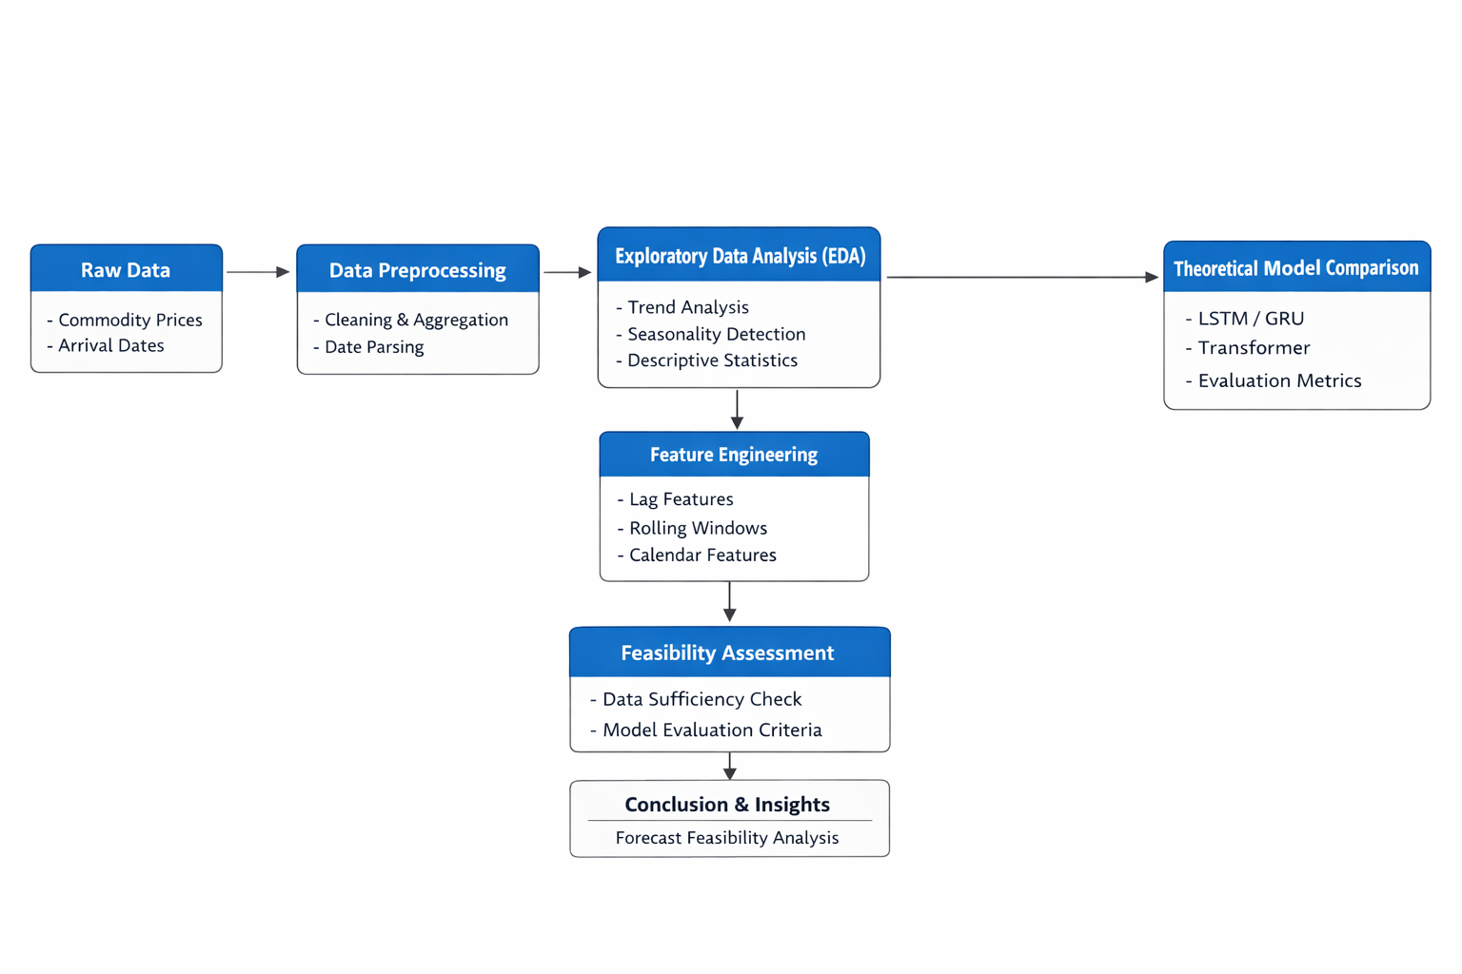

5.4 Model Architecture
Different machine learning and deep learning models were examined in this project to evaluate their suitability for agricultural commodity price prediction under real-world data constraints. Due to the limited temporal span and irregular time-series structure of the dataset for individual commodities, a feature-based machine learning approach was prioritised for reliable prediction.

5.4.1 Random Forest Regression Model
The Random Forest regression model was selected as the primary predictive model in this study. Random Forest is an ensemble learning technique that combines multiple decision trees to improve prediction accuracy and robustness. It is particularly effective for tabular datasets with engineered features and is capable of capturing non-linear relationships between input variables and target prices.
In this project, the Random Forest model was trained using lag-based features, rolling statistical measures, and calendar-based attributes derived from historical price data. The ensemble nature of the model helps reduce overfitting and provides stable performance even when the available time-series data is limited or irregular.

5.4.2 Recurrent Neural Network Models (LSTM and GRU)
Long Short-Term Memory (LSTM) and Gated Recurrent Unit (GRU) models were explored to assess their feasibility for agricultural price prediction. These models are designed to capture temporal dependencies in sequential data and are widely used in time-series forecasting tasks.
However, due to the short and uneven time-series length for individual commodity–market combinations, consistent and stable training of LSTM and GRU models was not achievable in the current study. As a result, these models were evaluated primarily from a feasibility and comparative perspective rather than being deployed as final predictive models.

5.4.3 Transformer-Based Models
Transformer-based architectures utilise attention mechanisms to model long-range dependencies in time-series data. While these models offer strong theoretical advantages, they typically require large and continuous historical datasets for effective training.
Given the limited temporal coverage of the available dataset, transformer-based models were analysed conceptually to understand their potential applicability but were not fully implemented for large-scale forecasting. This evaluation highlights the importance of data sufficiency when applying advanced deep learning models to agricultural price prediction tasks.

5.5 Hyperparameter Details
The following hyperparameters were used during model training and experimentation:
• Number of Trees (Random Forest): 100
• Maximum Tree Depth: Default (no explicit limit)
• Lag Window Size: 1–2 weeks
• Rolling Window Size: 3 weeks
• Train–Test Split Ratio: Chronological split (approx. 80:20)
• Optimisation Strategy: Mean Squared Error minimisation
These hyperparameters were selected to balance predictive performance and computational efficiency.

5.6 Loss Functions and Evaluation Criteria
Different evaluation metrics were used to assess model performance:
• Mean Absolute Error (MAE): Measures average absolute prediction error
• Root Mean Square Error (RMSE): Penalises larger errors and reflects prediction accuracy
• R² Score: Indicates the proportion of variance explained by the model
These metrics provide a comprehensive understanding of model accuracy and reliability in agricultural price prediction tasks.

6. Result and Evaluation
This section presents the experimental results and performance evaluation of the agricultural commodity price prediction system. The evaluation focuses on model behaviour, prediction accuracy, and limitations imposed by real-world data constraints. Both quantitative metrics and visual analysis are used for assessment.

6.1 Model Architecture Analysis
The primary predictive model evaluated in this study is the Random Forest Regressor. The model operates as an ensemble of decision trees trained on engineered features such as lag values, rolling statistics, and calendar-based attributes. Final predictions are obtained by averaging outputs from individual trees, improving generalisation and reducing overfitting.
Random Forest was selected due to its effectiveness on structured tabular data and its robustness under limited and irregular time-series conditions. Experimental results confirm that the model captures overall price trends and variability across commodities and markets.
Deep learning models, including LSTM, GRU, and Transformer-based architectures, were also implemented for comparative evaluation. Although these models were successfully trained, their performance was unstable and inferior due to insufficient sequence length and uneven data distribution. This analysis highlights the dependency of deep learning models on data continuity and volume.

6.2 Epoch-wise Error Trend Visualisation
Since Random Forest does not rely on epoch-based training, model behaviour was analysed through prediction error distributions and actual-versus-predicted price comparisons. Error patterns were examined to assess stability across different price ranges and time periods, particularly during volatile market conditions.
Figure 6.2: Actual vs Predicted commodity prices for Potato
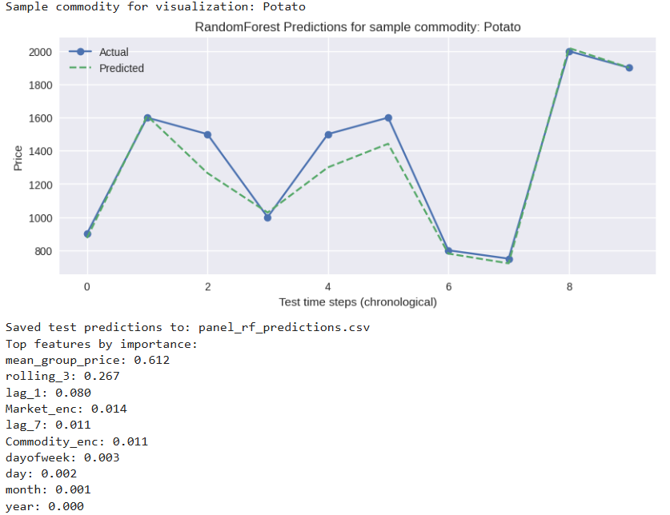

6.3 Training and Testing Performance Analysis
The Random Forest model achieved an RMSE of 1783.43, an MAE of 565.09, and an R² score of 0.8861 on the test dataset.
The high R² value indicates strong explanatory power over price variance. Minor degradation in test performance reflects market volatility and limited temporal depth, emphasising the need for cautious interpretation in real-world forecasting.
Fig 6.3: Performance metrics of the Random Forest model
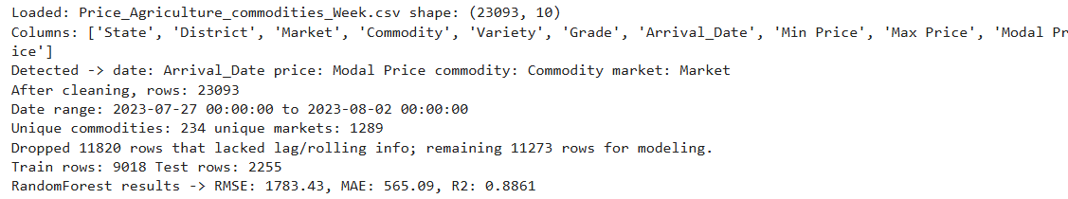

6.4 Quantitative Evaluation and Visualisation
Model performance was evaluated using RMSE, MAE, and R² metrics. To support quantitative results, actual versus predicted price plots were generated.
Potato was selected as a representative commodity due to relatively higher data availability. The plots show that predicted trends closely follow actual prices, with deviations during sudden market fluctuations, reflecting realistic agricultural price behaviour.
Table 6.4: Comparative performance of deep learning models
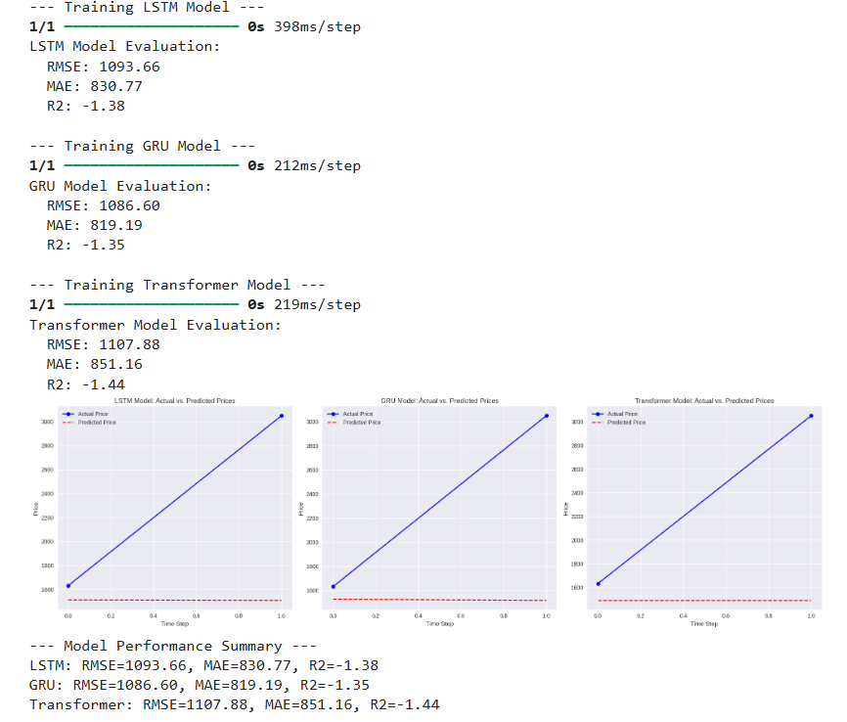

6.5 Model Complexity and Parameter Analysis
In addition to prediction accuracy, model complexity was analysed by examining the number of trainable parameters used in deep learning models. Parameter count is a critical factor in time-series forecasting, as models with a large number of parameters require sufficient data to generalise effectively.
In this study, LSTM, GRU, and Transformer-based models were implemented with relatively small architectures due to limited sequence length and dataset size. The total number of trainable parameters for each deep learning model was obtained using model summary outputs. Despite using lightweight configurations, the parameter count remained high relative to the available training samples, leading to unstable learning and reduced generalisation capability.
This analysis explains why deep learning models underperformed compared to the Random Forest model. While recurrent and attention-based architectures offer strong representational capacity, their parameter-heavy nature makes them sensitive to data scarcity. The findings reinforce that model complexity must be aligned with dataset scale for reliable agricultural price forecasting.
Model | Layer Type | Units/Configuration | Trainable Parameters
LSTM | LSTM | 32 units | 4352
 | Dense | Output: 1 | 33
GRU | GRU | 32 units | 3360
 | Dense | Output: 1 | 33
Transformer | Layer Normalisation | Input Shape (1,1) | 2
 | Multi-Head Attention | Key Dimensions & heads | 897
 | Dense | 64 units | 128
 | Dense | Output :1 | 65

7. Benefits of the Proposed System

The proposed agricultural commodity price prediction system offers several important benefits for various stakeholders involved in the agricultural supply chain. By leveraging historical market data and data-driven modelling techniques, the system provides meaningful insights into price behaviour and supports informed decision-making.
One of the primary benefits of the system is improved decision support for farmers. Reliable price predictions enable farmers to plan harvesting schedules, select appropriate markets, and decide optimal selling times, which can help reduce financial uncertainty and improve income stability. Early insights into potential price trends allow farmers to make proactive rather than reactive decisions.
The system also benefits traders and market intermediaries by supporting better procurement and inventory planning. Accurate forecasts assist in optimizing storage, transportation, and distribution strategies, thereby reducing operational inefficiencies and minimizing losses caused by sudden price fluctuations.
Another key advantage of the proposed system is its data-driven and transparent approach. The use of exploratory data analysis and interpretable machine learning models ensures that predictions are based on observable historical patterns rather than subjective assumptions. This transparency enhances trust in the system’s outputs and facilitates easier interpretation of results by non-technical users.
The proposed framework is also scalable and adaptable. While the current implementation focuses on selected commodities and short-term forecasting, the same methodology can be extended to additional commodities, markets, and longer time horizons as more data becomes available. The modular design allows integration of advanced models and external influencing factors in future enhancements.
Finally, the system contributes to policy planning and market regulation by providing analytical insights into price trends and volatility. Policymakers can use such information to design timely interventions, improve market transparency, and support price stabilisation measures. Overall, the proposed system serves as a practical foundation for developing intelligent, data-driven solutions in the agricultural domain.

8. Limitations and Challenges
Despite demonstrating the feasibility of agricultural commodity price prediction using data-driven approaches, the proposed system has certain limitations and challenges that must be acknowledged. These limitations primarily arise from the nature of real-world agricultural data and the constraints associated with advanced modelling techniques.
One major limitation of the system is the short and irregular time-series length available for individual commodities. Although the dataset contains a large number of records overall, the temporal coverage per commodity is limited, which restricts the ability of deep learning models to learn long-term dependencies and seasonal patterns effectively. This constraint impacts the reliability of complex models such as LSTM, GRU, and Transformer-based architectures.
Another challenge is the absence of external influencing factors in the dataset. Agricultural prices are affected by variables such as weather conditions, rainfall, transportation costs, fuel prices, inflation, and government policies. Since the current model relies primarily on historical price data, it may not fully capture sudden market shifts caused by these external factors.
The system also faces challenges related to data sparsity and uneven distribution across commodities and markets. Certain commodities have significantly fewer observations, which can lead to biased predictions and reduced generalization capability. Additionally, variations in reporting frequency across markets introduce inconsistencies that complicate time-series modeling.
From a modelling perspective, deep learning models require substantial computational resources and large datasets for stable training and optimal performance. Due to limited data availability, these models could not be fully exploited in the current implementation, necessitating reliance on feature-based machine learning approaches instead.
Finally, the system currently focuses on offline analysis and batch prediction, which limits its applicability for real-time forecasting scenarios. Deploying the system for live price prediction would require continuous data updates, robust data pipelines, and scalable infrastructure, which were beyond the scope of the present study.

9. Conclusion
This project focused on the analysis and prediction of agricultural commodity prices using historical market data and data-driven modelling techniques. The study emphasised understanding real-world agricultural price behaviour through systematic exploratory data analysis, feature engineering, and model evaluation. By analysing price trends, volatility, and temporal patterns, the project provided insights into the feasibility of applying predictive models for short-term agricultural price forecasting.
A feature-based ensemble learning approach using the Random Forest regression model demonstrated strong predictive performance on the available dataset. The model achieved high accuracy in capturing overall price trends, as reflected by a strong R² score, while maintaining relatively low error values. These results indicate that well-engineered features such as lag values, rolling statistics, and calendar-based attributes play a crucial role in improving prediction accuracy, especially when historical time-series data is limited.
The study also explored the applicability of deep learning models such as LSTM, GRU, and Transformer-based architectures. While these models are theoretically well-suited for time-series forecasting, their performance was constrained by the short and irregular time span of the available data. Challenges such as insufficient sequential depth and uneven data distribution across commodities limited the reliable training of deep learning models. This highlights the importance of data quality and continuity when applying advanced deep learning techniques to agricultural price prediction.
Overall, the project demonstrates that classical machine learning models, when combined with robust feature engineering and careful data preprocessing, can provide reliable and interpretable results under real-world data constraints. At the same time, the findings reinforce that deep learning approaches require longer and more consistent historical datasets to fully realize their potential. The insights obtained from this study contribute to a better understanding of the strengths and limitations of different modelling approaches for agricultural commodity price forecasting and can support future improvements in decision-support systems for the agricultural sector.

10. Future Scope
Although the current implementation demonstrates the feasibility of predicting agricultural commodity prices using historical market data and feature-based machine learning models, there is considerable scope for further enhancement. One important direction for future work is the use of longer and more continuous historical datasets spanning multiple seasons and years. Such data would allow deep learning models to effectively capture long-term trends, seasonal patterns, and complex temporal dependencies that could not be fully explored in the present study.
Future research can also focus on integrating additional external factors that influence agricultural prices, such as weather conditions, rainfall data, inflation indices, fuel prices, and government policy indicators. Incorporating these variables can improve model robustness and lead to more accurate and realistic price forecasts. Advanced feature engineering techniques and multivariate time-series modelling can further enhance predictive performance.
Finally, the proposed system can be extended into a real-time decision-support platform for farmers, traders, and policymakers. Deployment as a web-based or mobile application with interactive visualisations and real-time price updates would significantly enhance practical usability. Such extensions would make the system more scalable, accessible, and impactful in addressing real-world challenges in agricultural price forecasting.

References
Breiman, L. (2001). Random forests. Machine Learning, 45(1), 5–32.
https://doi.org/10.1023/A:1010933404324
Hochreiter, S., & Schmidhuber, J. (1997). Long short-term memory. Neural Computation, 9(8), 1735–1780.
https://doi.org/10.1162/neco.1997.9.8.1735
Makridakis, S., Spiliotis, E., & Assimakopoulos, V. (2018). Statistical and machine learning forecasting methods: Concerns and ways forward. PLoS ONE, 13(3), e0194889.
https://doi.org/10.1371/journal.pone.0194889
Zhang, G. P. (2003). Time series forecasting using a hybrid ARIMA and neural network model. Neurocomputing, 50, 159–175.
https://doi.org/10.1016/S0925-2312(01)00702-0
Sharma, R., Kamble, S. S., Gunasekaran, A., Kumar, V., & Kumar, A. (2020). A systematic literature review on machine learning applications for sustainable agriculture supply chain performance. Computers & Operations Research, 119, 104926.
https://doi.org/10.1016/j.cor.2020.104926
Kaggle. (2023). Current daily price of various commodities in India.
https://www.kaggle.com

